
Volume 2, No. 11 November 2023 - (1334-1345)
p-ISSN 2980-4868 | e-ISSN 2980-4841
https://ajesh.ph/index.php/gp

DISTRIBUTION PATTERN AND DENSITY FIGURE ON THE INCIDENT OF DHF

^{1*} Helfi Nolia,² Risnawati Tanjung,³Jernita Sinaga

^{1,2,3} Department of Environmental Health, Politeknik Kesehatan Kementerian Kesehatan Medan
Email : helfinolia@gmail.com

ABSTRACT:
Dengue hemorrhagic fever (DHF) is a disease that causes death, known for > 200 years, and has become a health problem in the world, especially in developing countries, including Indonesia. Deli Serdang Regency had the highest number of cases in North Sumatra Province in 2019, with 1,326 points. In 2020, there were 974 cases, IR: 50.4. In 2021, the Regency/City ranked 14th out of 514 Regency/City in Indonesia for the highest number of dengue fever cases in 2021 with 803 points, IR/morbidity rate: 34.63/100,000 population, CFR/death rate: 0.12%. It is possible to identify the location of the patient down to the address of the individual's site to obtain information regarding the distribution pattern of cases in each region using the Geographic Information System (GIS). This research aimed to bring a vector entomological survey (CI, BI, HI, ABJ) and the distribution pattern of Dengue Hemorrhagic Fever (DHF). The study used a case-control design, determining the location of houses referring to FUNASA and WHO regulations (taking into account the number of buildings and House Index (HI) with household members as subjects of 100 case houses and 100 control houses consisting of 22 sub-districts in Deli Serdang Regency. Based on the distribution results using Stascan, there are 4 clusters, and the case points for dengue fever sufferers are located at a distance of 500 - 1500 m from the Community Health Center. Data on dengue fever sufferers in each community health center buffer in Deli Serdang Regency contained 81 cases.

Keywords: Distribution Pattern, DBD, Density Figure

INTRODUCTION
Dengue hemorrhagic fever is a disease that has been known for > 200 years and has become a health problem in the world, especially in developing countries (Hasyim, 2008). This disease is endemic in 100 countries, infecting more than 50 – 100 million people. Five hundred thousand cases of dengue fever require hospital treatment, and 22,000 instances die every year (Sulistyo, 2019).
In 2021, the number of dengue fever sufferers in 34 provinces in Indonesia will be 73,518 cases, the IR/morbidity rate will be 27/100,000 population, and the CFR/mortality rate will be 0.96%. The morbidity rate/IR of dengue fever cases in North Sumatra Province in 2021 is 19.51/100,000 population, and the CFR is 0.48% (Akbar & Hamzah, 2021).
Deli Serdang Regency had the highest number of cases in North Sumatra Province in 2019, with 1,326 points, in 2020, there were 974 cases, IR: 50.4. In 2021, the Regency/City ranked 14th out of 514 Regency/City in Indonesia for the highest number of dengue fever cases in 2021, 803 points, IR/morbidity rate: 34.63/100,000 population, CFR/mortality rate: 0.12% (Atikasari & Sulistyorini, 2018). Based on sensitivity tests in North Sumatra Province in 2015, alpha-cypermethrin 0.025% showed a value above 80%. The insecticide cypermethrin 0.05% of mosquitoes that died in Deli Serdang Regency was only 70%, deltamethrin 0.025% showed deaths above 90%, the percentage of mosquito deaths from the Pematang Siantar and Tebing Tinggi areas below 80%. Central Java and DI Yogyakarta mostly of Egyptians resistant to insecticides used in control activities bendiocarb 0.1%, lambda-cyhalothrin 0.05%, permethrin 0.75%, deltamethrin 0.05%, and etofenprox 0.5. Ikawati et al. stated cypermethrin resistance was 0.05% in the Temples of the Egyptians in nine districts in Central Java. Mosquitoes show moderate resistance to cypermethrin in Ngawonggo and Kajen Villages, with a mortality of 97%. Meger Village offers a resistant status with a mortality of 89% (Niroui et al., 2015).
Prevention and control of dengue fever with PSN 3 M Plus activities and the one house one jumantik movement (G1R1J) has not yet been implemented in Deli Serdang Regency, so there is no data on the risk of dengue transmission (BI, CI, HI, ABJ and density figures). Controlling the dengue vector in Deli Serdang Regency uses CYNOFF 50 EC, which contains the active ingredient cypermethrin 50 gr/lt.

RESEARCH METHODS
The type of research used is observational research with a case-control design. The research location is Deli Serdang Regency from January to September 2023. The ratio used for case-control is 1:1 (100 cases and 100 controls) data collection for the distribution of dengue fever using GPS to obtain GIS data.
Collecting data on several factors causing dengue fever using a questionnaire with observation sheets, characteristics including density figures and larva collection using a Vitra and Garmin Etrex 10 type GPS, map source, Quantum GIS, and Google Earth to collect coordinates of dengue cases living in Deli Serdang Regency. Data analysis is done by analyzing the average nearest neighbor used to see the distribution pattern of dengue fever incidents in the Deli Serdang Regency.
RESULTS AND DISCUSSION
Distribution Pattern of Dengue Fever Incidence Dengue (DBD)

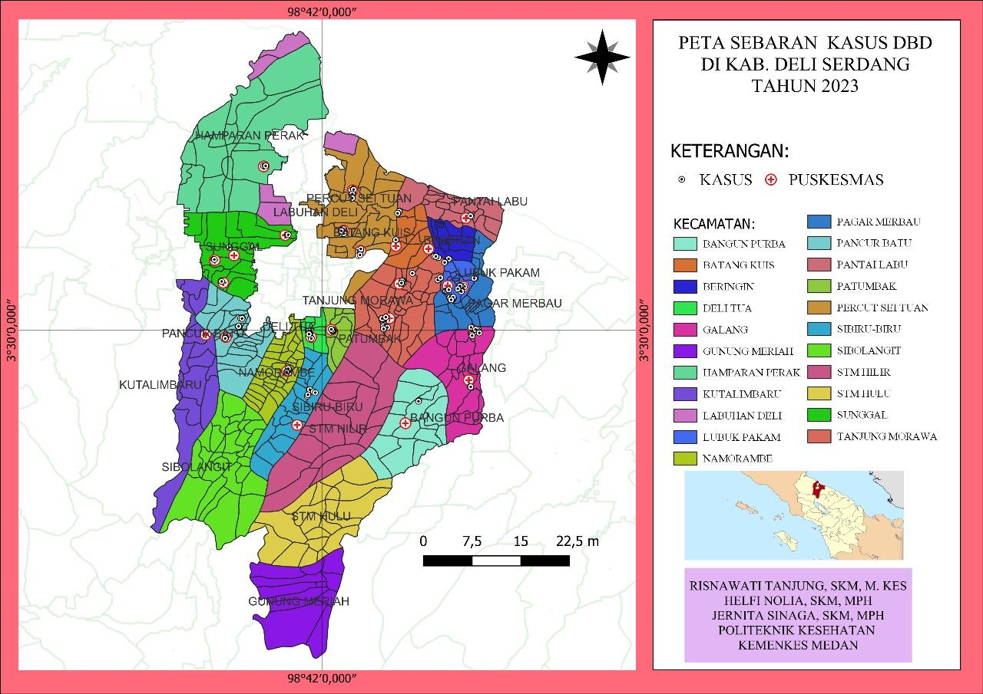

Figure 1 . Distribution of DHF Cases in Deli Serdang Regency

The spread of dengue fever cases in Deli Serdang Regency occurred in several sub-districts, so several did not experience dengue cases. Based on the research results, the most points were in Tanjung Morawa District, with 34 points, including Bandar Labuhan with two people, Limau Manis with 32 people, and Deli Tua District with 2 cases. Next, the distribution of cases is analyzed using the method of average nearest neighbor analysis to determine the distribution pattern. The indicator used is the nearest neighbor index number by considering the average.

Distance from the point of each case coordinate. Based on the results using Stascan, there are 4 clusters with the most likely cluster. There were 14 cases, p-value <0.0001; RR: 2.28; radius: 6.45 km, which means there is a grouping of instances (groups) that are most at risk, having a risk level of 2.28 times getting dengue fever for sufferers who are inside the cluster compared to sufferers who are outside the group with a cluster radius of 6, 45 km. The second cluster contained 9 cases, p-value <0.00001; RR: 4.84; radius: 9.08 km, which means that there is a grouping of instances (groups) that are most at risk, having a risk level of 4.84 times getting dengue fever for sufferers who are inside the cluster compared to sufferers who are outside the group with a cluster radius of 9, 08 km.
The third cluster contained 7 cases, p-value <0.0001; RR: 5.18; radius: 4.48 km, which means that there is a grouping of instances (clusters) that are most at risk, having a risk level of 5.18 times getting dengue fever for sufferers who are inside the group compared to sufferers who are outside the group with a cluster radius of 4, 48 km. The fourth cluster contained 6 cases, p-value <0.00001; RR: 3.86; radius: 3.83 km, which means that there is a grouping of instances (clusters) that are most at risk, having a risk level of 3.86 times of getting dengue fever for sufferers who are inside the group compared to sufferers who are outside the group with a cluster radius of 3, 83 km, as shown below:
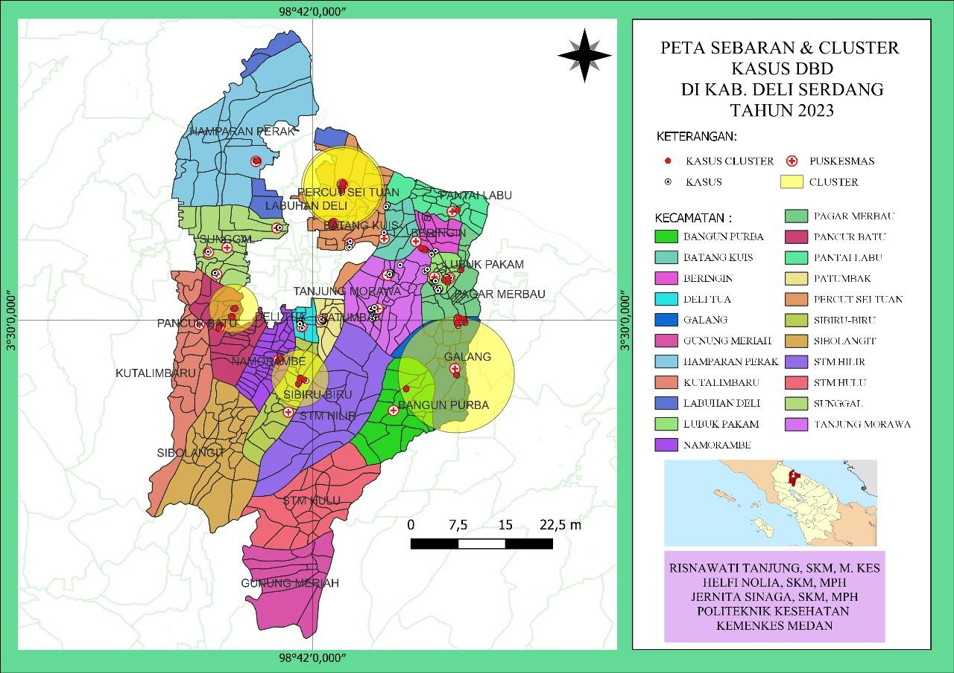

Figure 2. Nearest Neighbor Analysis and Distribution of DHF Cases in Deli Serdang Regency in 2023

Next, we can see the distribution of cases based on population density in Deli Serdang Regency:
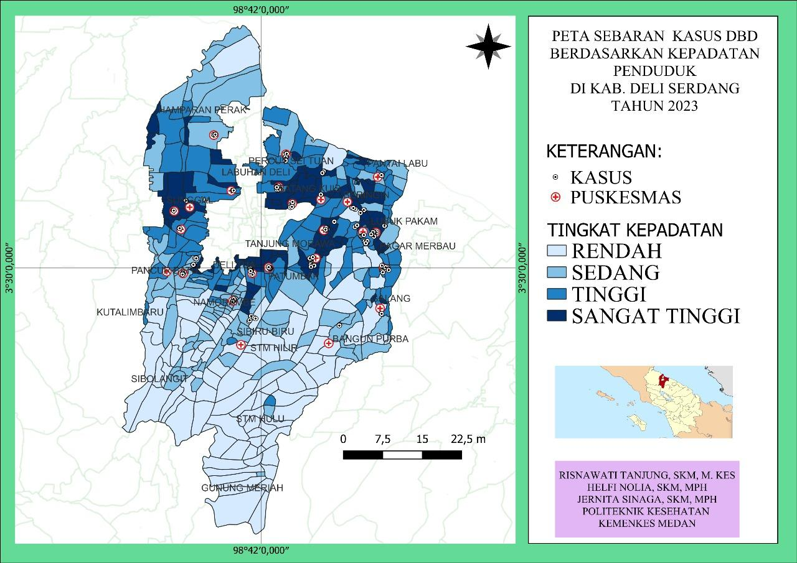

Figure 3. Map of Case Distribution Based on Population Density in Deli Serdang Regency in 2023

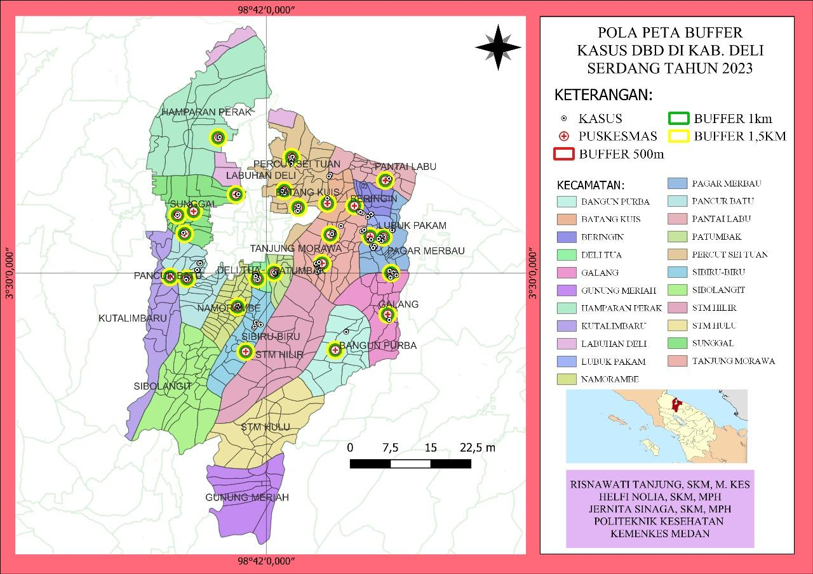

Figure 4. Buffer Map of DHF Cases in Deli Serdang Regency in 2023

Referring to the picture above, the case point for dengue fever sufferers is 500 - 1500 m from the Puskesmas. Data on dengue fever sufferers in each community health center buffer in Deli Serdang Regency contained 81 cases.

Larvae Presence Variable
Univariate analysis presents descriptive data including numbers and percentages. The table shows that of the Two hundred houses were examined, and 74 homes were found to have larvae. So, the house index earned 37, which shows in density figures at medium larva density (Tambunan, 2013). From this table, it can also be obtained that the larvae-free rate (ABJ) is 63%. $House index\left(HI\right)=\frac{Number of Houses+}{Number of Houses Inspected}X 100\%$
$$House index\left(HI\right)=\frac{74}{200}X 100\%$$
House Index (HI) = 37 %

Table 1
Frequency Distribution of Research Subjects Based on the Presence of Larvae at Home
in Deli Serdang Regency

No | The existence of larvae | Amount  (n) | Percentage  (%)
1 | There is | 74 | 37.
2 | No | 126 | 63.0
Total |  | 200 | 100.0

$$Flick Free Numbers\left(ABJ\right)=\frac{Number of Larvae Free Homes}{Number of Homes Inspected}X 100\%$$
$Flick Free Numbers\left(ABJ\right)=\frac{126 }{200 }X 100\%$

Larval Free Rate (ABJ) = 63 %

Table 2
Frequency Distribution of Research Subjects Based on
The presence of larvae in containers in Deli Serdang Regency

No | Water reservoirs | The existence of larvae |  |  |  | TOTAL
No | Water reservoirs | There is |  | No
No | Water reservoirs | n | % | n | % | N | %
1 | Bucket in the house | 16 | 8,0 | 184 | 92,0 | 200 | 100
2 | Outdoor bucket | 12 | 6,0 | 188 | 94,0 | 200 | 100
3 | Animal Drinking Place in the House | 2 | 1,0 | 198 | 99,0 | 200 | 100
4 | Outdoor Animal Drinking Place | 4 | 2,0 | 196 | 98,0 | 200 | 100
5 | Used goods in the house | 7 | 3,5 | 193 | 96,5 | 200 | 100
6 | Used goods outside the home | 20 | 10,0 | 180 | 90,0 | 200 | 100
7 | Flower Vase in the House | 1 | ,5 | 199 | 99,5 | 200 | 100
8 | Flower Vases outside the House | 1 | ,5 | 199 | 99,5 | 200 | 100
9 | Refrigerator Storage in the Home | 0 | 0 | 200 | 100,0 | 200 | 100
10 | Outdoor Refrigerator Storage | 0 | 0 | 200 | 100,0 | 200 | 100
11 | Water channel in the house | 1 | ,5 | 199 | 99,5 | 200 | 100
12 | Outdoor Water Channels | 1 | ,5 | 199 | 99,5 | 200 | 100
13 | Storage of Dispensers in the House | 3 | 1,5 | 197 | 98,5 | 200 | 100
14 | Outdoor Dispenser Housing | 1 | ,5 | 199 | 99,5 | 200 | 100
15 | Bathtub in the house | 8 | 4,0 | 192 | 96,0 | 200 | 100
16 | Outdoor bathtub | 0 | 0 | 200 | 100,0 | 200 | 100

The table shows that 3,200 containers were obtained from the 200 houses inspected. There are 77 containers containing larvae. So Container index received: 2.4 This shows indensity figures at low density (1).
$$Container Index\left(THERE\right)=\frac{Number of Positive Flick Containers}{Number of Containers Inspected}X 100\%$$
$$Container Index\left(THERE\right)=\frac{77 }{3200}X 100\%$$
Container Index (HI) = 2,4 %
Distribution Pattern of DHF Incidence
The analysis results using Units show 4 clusters with the most likely cluster. There were 14 cases, p-value <0.000001; RR: 2.28; radius: 6.45 km, which means that there is a grouping of instances (clusters) that are most at risk, having a risk level of 2.28 times getting dengue fever for sufferers who are inside the group compared to sufferers who are outside the cluster with a cluster radius of 6, 45 km. The second cluster contained 9 cases, p-value <0.0001; RR: 4.84; radius: 9.08 km, which means that there is a grouping of instances (groups) that are most at risk, having a risk level of 4.84 times getting dengue fever for sufferers who are inside the cluster compared to sufferers who are outside the group with a cluster radius of 9, 08 km.
The third cluster contained 7 cases, p-value <0.0001; RR: 5.18; radius: 4.48 km, which means there is a grouping of instances (groups) that are most at risk, having a risk level of 5.18 times getting dengue fever for sufferers who are inside the cluster compared to sufferers who are outside the group with a cluster radius of 4, 48 km. The fourth cluster contained 6 cases, p-value <0.00001; RR: 3.86; radius: 3.83 km, which means that there is a grouping of instances (groups) that are most at risk, having a risk level of 3.86 times of getting dengue fever for sufferers who are inside the cluster compared to sufferers who are outside the group with a cluster radius of 3, 83 km.
The results of analysis using the Qgis application show that population density is related to the level of distribution of dengue fever cases. The higher the population density in an area, the higher the risk of disease transmission in that area. This is supported by research (Kusuma & Sukendra, 2016), which states that the prevalence of dengue fever cases is spatially related to population density and (Bakhtiyar et al., 2012) population density factors influence the process of transmission or transfer of disease from one person to another. Other. The denser the population eats, the more conducive it is for the virus to reproduce, which can increase in cases.
The existence of larvae
Water reservoirs (TPA) are said to be positive as mosquito breeding places. aegypti is marked by the discovery of larvae Ae Aegypt in the landfill. The water reservoirs most frequently found positive for larvae in this study were used items outside the house (10.0%), buckets inside the house (8.0%), buckets outside the home (6.0%) and bathtubs inside the house (4.0%). The preferred place for the primary vector of dengue fever is standing water in artificial water storage containers, drums, bathtubs, buckets, not water reservoirs, for example, flower vases, used tires, used bottles, bird drinkers and so on. Containers outside the house are at risk of larvae because it is easy for mosquitoes to breed naturally in containers. This is because, on average, all containers are left open and often hold large amounts of water in the community, so this becomes a favorite place for mosquitoes. Aedes sp to reproduce. Apart from that, people are known to rarely and forget to drain the water in the bathtub or water storage bucket, resulting in mosquito eggsAedes sp that stick to the container walls can breed into larvae and adult mosquitoes (Aulia et al., 2018).
House Index (HI) calculates the risk of disease spread and describes the extent of mosquito distribution in an area. This index indicates the percentage of homes that are positive for breeding, indicating the human population at risk of dengue fever. So, the house index obtained: 37 shows indensity figures at medium larva density (5). The results of research in Deli Serdang Regency show that the larval population density is the degree of transmission of dengue fever dengue (DHF), which is carried by mosquito vectors Aedes sp is moderate, so you need to pay attention and be aware of the potential for high cases of dengue hemorrhagic fever (DHF). House Index (HI) better describes the extent of mosquito distribution in an area. The distance between houses influences the spread of mosquitoes from one place to another. The closer a home is, the easier it is for mosquitoes to spread because Aedes sp mosquitoes can fly 40-50 meters (Aulia et al., 2018).
Container Index (CI) describes the percentage of positive containers for Ae larvae. Aegypti. Certain areas may have few larvae-positive containers but still be epidemiologically vital because they produce large numbers of larvae. On the other hand, certain areas may have many positive containers. Still, these containers only make a small number of larvae, so epidemiologically, there is less risk of an extraordinary event (KLB). Shows that 3,200 containers were inspected from 200 houses. There are 77 containers containing larvae. So Container index obtained: 2.4 This shows indensity figures at low density. The birth of Aedes sp mosquito larvae in containers in the house, such as bathtubs, toilets, drums, and water storage buckets, because people drain the water more than once a week and the method of draining the water is not appropriate, such as not brushing the walls of the container until clean so that the eggs that stick to it can continue. Metamorphosis cycle into larvae. Water reservoirs have the potential to become breeding grounds for Aedes sp mosquitoes. This is because the water reservoir is not closed, moist, and protected from direct sunlight. The Aedes sp mosquito lays its eggs in clear water so that the mosquito can carry out its life cycle in that place, namely from egg to larva to pupa and then becomes an adult mosquito.
The larvae-free number (ABJ) is the presence of larvae aegypti in water reservoirs, which can become a breeding ground for mosquitoes inside and outside the house. The larvae-free rate (ABJ) from research results in Deli Serdang Regency was 63%. Larval-free rate (ABJ) = 63% indicates a lousy category if the larvae-free rate (ABJ) is ≤ 95%. This means there is still a lack of implementation of eradicating mosquito nests in the Deli Serdang Regency because the success of PSN activities can be measured by the Larva Free Rate (ABJ). If ABJ ≤ 95%, it is expected to prevent or reduce cases of dengue fever transmission. Several things that influence the density of mosquito larvae Aedes sp are the existence of containers that become breeding grounds for Aedes sp mosquitoes in the environment inside the house or outside the house and the behavior of people in cleaning water reservoirs more than once a week. Vector control can be done by cleaning mosquito nests (PSN) by reducing breeding sites, carrying out 3M Plus activities, draining water reservoirs regularly once a week, closing water reservoirs, and getting rid of used items that can hold water administering larvicides, fogging with malathion in outbreak or endemic areas, and public health education to protect the environment (Aulia et al., 2018).

CONCLUSION
This research concludes: Based on the distribution results using Stascan, there are 4 clusters, and the case points for dengue fever sufferers are 500 - 1500 m from the Puskesmas. Data on dengue fever sufferers in each community health center buffer in Deli Serdang Regency contained 81 cases. The house index obtained is 37; this shows that the density figure is medium larva density (5). The larvae-free rate (ABJ) was obtained at 63%. The container index obtained is 2.4. This shows the density figure at low density.

BIBLIOGRAPHY
Akbar, H., & Hamzah, B. (2021). Identifikasi Kepadatan Larva Nyamuk Aedes Sp Sebagai Vektor Penyakit Demam Berdarah Dengue di Kelurahan Mogolaing Kotamobagu. Afiasi: Jurnal Kesehatan Masyarakat, 6(2), 127–133.
Atikasari, E., & Sulistyorini, L. (2018). Pengendalian vektor nyamuk aedes aegypti di rumah sakit kota surabaya. The Indonesian Journal of Public Health, 13(1), 71–82.
Aulia, A., Hulla, C., Khairu, A., Anggol, U., & Akbar, H. (2018). Identifikasi Kepadatan Larva Nyamuk Aedes Sp Sebagai Vektor Penyakit Demam Berdarah Dengue di Kelurahan Mogolaing Kotamobagu Identification of Aedes Sp Mosquito Larvae Density as a Vector of Dengue Hemorrhagic Fever in Mogolaing Village, Kotamobagu. 6(2), 127–133.
Hasyim, H. (2008). Manajemen Penyakit Lingkungan Berbasis Wilayah. Jurnal Manajemen Pelayanan Kesehatan, 11(02).
Kusuma, A. P., & Sukendra, D. M. (2016). Analisis Spasial Kejadian Demam Berdarah Dengue Berdasarkan Kepadatan Penduduk. Unnes Journal of Public Health, 5(1), 48. https://doi.org/10.15294/ujph.v5i1.9703
Niroui, F., Sletten, E. M., Song, Y., Wang, A. I., Ong, W. J., Kong, J., Yablonovitch, E., Swager, T. M., Lang, J. H., & Bulović, V. (2015). Tunneling nanoelectromechanical switches. 2015 Fourth Berkeley Symposium on Energy Efficient Electronic Systems (E3S), 1–3.
Sulistyo, A. (2019). Kombinasi teknologi aplikasi gps mobile dan pemetaan sig dalam sistem pemantauan demam berdarah (DBD). Khazanah Informatika: Jurnal Ilmu Komputer Dan Informatika, 5(1), 6–14.
Tambunan, H. N. R. (2013). Faktor Lingkungan Dan Kejadian Demam Berdarah Dengue (DBD) Daerah Endemis Kecamatan Gading Cempaka Kota Bengkulu Tahun 2012. Universitas Gadjah Mada.
Achmadi, U. F. (2019) ‘Manajemen Penyakit Lingkungan Berbasis Wilayah’, Jurnal Manajemen Pelayanan Kesehatan, 11(02), pp. 72–76.
A. Sulistyo, A. Yudhana, R. Aini, and U. A. Dahlan, “khazanah informatika Kombinasi Teknologi Aplikasi GPS Mobile dan Pemetaan SIG dalam Sistem Pemantauan Demam Berdarah ( DBD ),” vol. 5, no. 1, pp. 6–14, 2019.
Aulia, A. et al. (2018) ‘Identifikasi Kepadatan Larva Nyamuk Aedes Sp Sebagai Vektor Penyakit Demam Berdarah Dengue di Kelurahan Mogolaing Kotamobagu Identification of Aedes Sp Mosquito Larvae Density as a Vector of Dengue Hemorrhagic Fever in Mogolaing Village, Kotamobagu’, 6(2), pp. 127–133.
E. Atikasari, “Pengendalian vektor nyamuk aedes aegypti di rumah sakit kota surabaya,” no. July, pp. 71–82, 2018, doi: 10.20473/ijph.vl13il.2018.71-82.
G. P. W. Indri Grysela Karauwan, Janno B B Bernadus, “Uji Resistensi Nyamuk AEDES AEGYPTY DEWASA TERHADAP CYPERMETHRIN DI DAERAH PASAR TUA BITUNG 2016,” Kedokt. Klin., vol. 1, no. 3, pp. 42–46, 2017, doi: 10.1109/E3S.2015.7336790.
H. Nolia, “Faktor Lingkungan Dan Kejadian Demam Berdarah Dengue (Dbd) Daerah Endemis Kecamatan Gading Cempaka Kota Bengkulu Tahun 2012,” 2013.
Kusuma, A. P. and Sukendra, D. M. (2016) ‘Analisis Spasial Kejadian Demam Berdarah Dengue Berdasarkan Kepadatan Penduduk’, Unnes Journal of Public Health, 5(1), p. 48. doi: 10.15294/ujph.v5i1.9703.
Kemenkes, “Validasi Data,” no. 1, 2022.
N. Halimah, “Proyeksi dan Pemetaan Wilayah Sebaran Balita Stunting Di Kota Makassar Berbasis Sistem Informasi Geografi ( SIG ) Projection and Mapping Areas of Distribution of Stunting Children in Makassar City Based on Geographic Information System ( GIS ),” Jurnal.Unismuhpalu.Ac.Id, vol. 10, pp. 173–184, 2020, [Online]. Available: http://jurnal.unismuhpalu.ac.id/index.php/PJKM/article/view/1371.
N. Irawati, “RESISTENSI NYAMUK Aedes aegypti TERHADAP CYPERMETHRIN DI KABUPATEN KLATEN , JAWA TENGAH,” vol. 15, no. 1, pp. 1–7, 2021.
O. Lesmana and R. Halim, “Gambaran Tingkat Kepadatan Jentik Nyamuk Aedes Aegypti di Kelurahan Kenali Asam Bawah Kota Jambi.,” J. Kesmas Jambi, vol. 4, no. 2, pp. 59–69, 2020, doi: 10.22437/jkmj.v4i2.10571.
Profil Dinkes Kab.Deli Serdang, “PROFIL DINAS KESEHATAN KAB.DELI SERDANG,” no. I, 2022.
R. Tanjung, E. L. Mahyuni, N. Tanjung, O. S. Simarmata, J. Sinaga, and H. R. Nolia, “The spatial distribution of pulmonary tuberculosis in Kabanjahe District, Karo regency, Indonesia,” Open Access Maced. J. Med. Sci., vol. 9, pp. 817–822, 2021, doi: 10.3889/oamjms.2021.6808.
S. G. Purnama, T. Baskoro, and Y. Prabandari, “PEMETAAN SPATIAL KASUS INFEKSI DENGUE DAN UJI KERENTANAN AEDES AEGYPTI PADA ORGANOFOSFAT,” J. ILMU Kesehat. Masy., vol. 4, 2013, [Online]. Available: https://ejournal.fkm.unsri.ac.id/index.php/jikm/article/view/275/219.
W. Wang et al., “Demam Berdarah Dengue Tinjauan literatur sistemik dari perspektif saat ini tentang patogenesis , pencegahan dan pengendalian,” 2020, doi: 10.1016/j.jmii.2020.03.007.
WHO, “Dengue in the WHO European Region,” Dengue WHO Eoropean Reg., 2020, [Online]. Available: https://www.euro.who.int/__data/assets/pdf_file/0009/234198/Dengue-in-the-WHO-European-Region.pdf
Dinas Kesehatan Provinsi Sumatera Utara, Profil Dinas Kesehatan Profinsi Sumatera Utara. 2019. [Online].Available: http://dinkes.sumutpov.go.id/common/upload/d9/93344c3888193ac75711f1fae30e9b_Buku Profil Kesehatan 2019.pdf
Jernita & Likas, “Identifikasi dan distribusi nyamuk Aedes SP. Sebagai Prevalensi Penyakit Demam Berdarah Dengue Di Kabupaten Karo,” Penelitian, pp. 54–78, 2019, [Online]. Available: http://poltekkes.aplikasi-akademik.com/xmlui/handle/123456789/2316
M. F. Ernyasih, Rafika zulfa, Andriyani, “Analisi Spasial Kejadian Demam Berdarah Dengue di Kota Tangerang Selatan Tahun 2016-2019,” vol. 01, pp. 74–98, 2020.
Kasman. and N. I. Ishak, “Analysis of Diseases of Dengue Healthy Fever Diseases,” Indones. J. Heal. Promot., vol. 1, no. 2597–6052, pp. 32–39, 2018, [Online]. Available: ttps://www.mendeley.com/catalogue/analisis-penyebaran-penyakit-demam-berdarah-dengue-di-kota-banjarmasin-tahun-20122016/%0D
H. N. R. Tambunan, “Faktor Lingkungan Dan Kejadian Demam Berdarah Dengue (Dbd) Daerah Endemis Kecamatan Gading Cempaka Kota Bengkulu Tahun 2012,” 2013, [Online]. Available: http://etd.repository.ugm.ac.id/index.php?mod=penelitian_detail&sub=PenelitianDetail&act=view&typ=html&buku_id=67427

Copyright holder:
Martha Khusnul Aulia, Irwan Bagyo Santoso (2023)
First publication right:
Asian Journal of Engineering, Social and Health (AJESH)
This article is licensed under:

