
Volume 3, No. 6 June 2024 (1170-1178)
p-ISSN 2980-4868 | e-ISSN 2980-4841
https://ajesh.ph/index.php/gp

Case Report on a 3-year-old Child Who Underwent Video Assisted Thoracoscopy Surgery (VATS) Bullectomy with One Lung Ventilation (OLV) technique

I Putu Kurniyanta^{1*}, I Made Pasek Budiadnyana², Tjokorda Gde Agung Senapathi³, Kadek Agus Heryana Putra⁴, Otniel Adrians Labobar⁵, I Wayan Sudarma⁶
^{1,2,3,4,5,6} Udayana University, Denpasar, Bali, Indonesia
Email: putukurniyanta@gmail.com

ABSTRACT
One-lung ventilation (OLV) is a crucial technique used in thoracic surgery, such as lobectomy or pneumonectomy, to isolate one lung and provide optimal surgical exposure while maintaining ventilation. Contrary to the misconception that OLV using Fogarty catheters is not applied in children, this technique is widely used in pediatric anesthesia, particularly during thoracic surgeries. A three-year-old child weighing 15.3 kg presented with a one-week history of coughing and a one-day history of shortness of breath at Prof. Dr. I.G.N.G. Ngoerah General Hospital, Denpasar. A chest tube was installed to alleviate tightness, and a thoracic CT scan revealed multiple cavities with consolidation in both inferior lung lobes. The surgeons opted for a bullectomy using the Video-Assisted Thoracoscopic Surgery (VATS) technique. In this case, OLV was achieved using a single-lumen endotracheal tube (ETT) and a Fogarty embolectomy catheter as a bronchial blocker (BB) to replace the fiberoptic bronchoscope (FOB) device. The ballooning-based BB method proved to be an effective alternative for lung isolation. This case demonstrates that using Fogarty catheters for OLV in pediatric thoracic surgery is feasible and effective, highlighting the importance of understanding pediatric and thoracic anesthesia principles to ensure safe and efficient anesthesia care during these procedures, while also addressing the specific dangers and challenges during the perioperative phase.
Keywords: Bullectomy, Fogarty Catheter, One-Lung Ventilation, VATS.

INTRODUCTION
Over the past few years, progress has been made in developing the One Lung Ventilation (OLV) approach for newborns and children, although it is currently only used in certain situations (Templeton et al., 2021). Lung resection, decortication, diaphragmatic hernia repair, minimally invasive cardiac surgery, aortic arch surgery, and operations related to esophageal surgery are some of the thoracic surgical procedures that can benefit from OLV. The primary methods of OLV procedures in children, such as endobronchial intubation or extraluminal bronchial blocker (BB) implantation, remain largely the same. One-lung ventilation using Fogarty catheters is not applied in children. In fact, the technique is widely used in pediatric anesthesia, particularly during thoracic surgeries. The Fogarty catheter is commonly employed as a bronchial blocker to achieve lung isolation, which is essential for certain surgical procedures (Behera et al., 2022). Although OLV techniques for anesthesia in children are still uncommon, the field is still evolving due to advances in surgical methods, a better understanding of lower airway anatomy in pediatric patients, the creation of new BBs, and creative processes of extraluminal BB insertion (Yao et al., 2022).
A minimally invasive surgical technique called Video Assisted Thoracoscopic Surgery (VATS) is used to identify and treat problems in the chest cavity. One of the lungs must be isolated to provide anesthesia before using this method. The OLV technique is the technique used for VAT; it is used because it maintains lung health and provides improved visualization of the surgical site. Because this approach can reduce postoperative problems and discomfort, the VATS approach is the surgical method of choice for pediatric patients with the advantages of shorter hospital stays and fewer surgical procedures (Kiblawi et al., 2021).
A Fogarty catheter is often used in adult patients to isolate specific lung areas during OLV. The Fogarty catheter approach can be used in pediatric patients, although its prevalence is lower than DLT or BB (Boisen et al., 2022). This is especially true when DLT or BB is not possible or unavailable. For thoracic surgery that requires selective lung isolation, such as lung resection, thoracoscopic procedures, correction of congenital heart defects, and corrective surgery for thoracic deformities, a Fogarty catheter approach for OLV in children is required (Murray-Torres et al., 2021).
Challenges in using the OLV approach in the pediatric population stem from the double-lumen tube (DLT) rarity and the limited availability of appropriate airway management technology for this age group. Therefore, unique approaches and equipment must be used when applying OLV techniques to children (Tognon et al., 2022). The OLV procedure in a 3-year-old child undergoing bullectomy with the VATS technique is reported in this study. This study aimed to document the author's method for performing OLV in pediatric patients after VATS surgery.

RESEARCH METHODS
The case report method was used in this study to describe in detail the clinical management and treatment outcome of a three-year-old child who experienced acute cough and shortness of breath, and was found to have multiple cavities in the inferior lobe of the right and left lungs with surrounding consolidation. Through this method, the study was able to provide in-depth information regarding the diagnosis, surgical intervention using the VATS technique, as well as the use of pulmonary ventilation with OLV utilizing the Fogarty catheter as an alternative in pediatric patients. This is important as this case provides valuable insights into rare clinical management and specific procedures that can be applied to similar pediatric patient populations, which have not been widely reported in the medical literature.

RESULTS AND DISCUSSION
A three-year-old child weighing 15.3 kgs came to the emergency department; Prof. Dr. I.G.N.G. to the general hospital, Denpasar, with complaints of coughing that had occurred one week before entering the hospital and shortness of breath that had been experienced since the day before entering the hospital. The patient then underwent a chest X-ray examination and found multiple thick-walled cavities in the lower zone of the right and left lungs (Proschek & Vogl, 2016). The thoracic imaging examination was then continued with a CT scan of the thorax with contrast, and a picture of multiple cavities was obtained in the anterobasal segment of the inferior lobe of the right lung and the posterobasal segment of the inferior lobe of the left lung with surrounding consolidation. Thoracic CT scan examination with contrast also found leukemic lung involvement with a fistula between the cavity and the right pleural cavity; multiple nodules in the superior lobe, middle lobe, inferior lobe of the right lung, and superior lobe, inferior lobe of the left lung, suggestive of leukemic lung involvement, multiple lymphadenopathies in the right upper-lower paratracheal region and suitable and left supraclavicular, right fluid pneumothorax, cardiomegaly (CTR 61 %), hepatomegaly, and emphysema subcutis soft tissue of the right hemithorax. The patient was then treated in the emergency room with a needle thoracocentesis procedure on the right hemithorax using local anesthesia, then continued with the installation of a water-sealed drainage (WSD) tube with serous production and the patient was observed in the Pediatric Intensive Care Unit (PICU). The thoracic and cardiovascular surgeon then decided to perform a bullectomy using the VATS technique on the patient (RAHMAN et al., 2023).

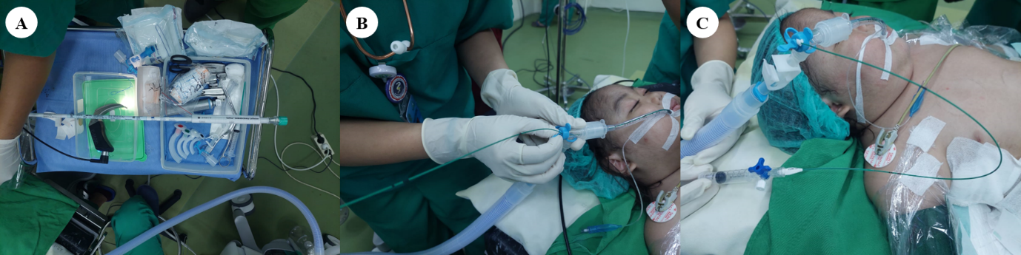
Figure 1. Bronchial block procedure in a patient. (A) Forgaty catheter preparation, (B) Forgaty catheter placement, (C) Side view procedure.

Surgery is prepared by ensuring the patient fasts from solid food for at least eight hours before anesthesia and other standard monitoring (Merchant et al., 2020). Apart from that, a pediatrician calculated the required fluids and doses, and an examination of the estimated tube depth was evaluated using a CT scan, an L-Connector with a silicone cap, and end-tidal CO2 (EtCO2) monitoring. Apart from that, temperature probes and ready-to-use blood components are also prepared for bleeding manipulation during surgery.

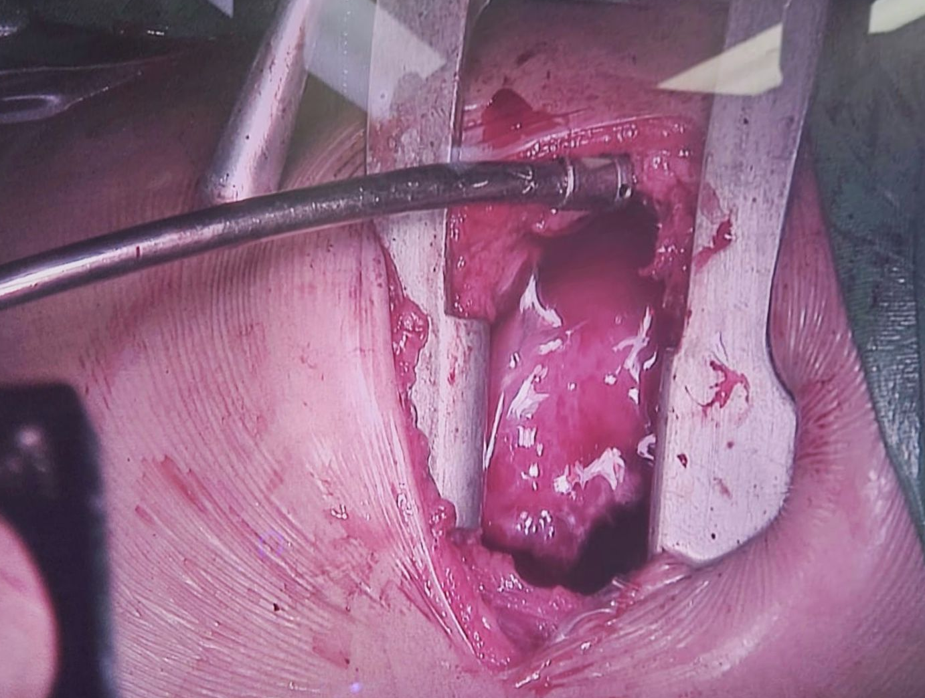
Figure 2. One Lung Ventilation Procedure

Anesthesia begins with premedication with 0.5 mg midazolam and 10 mg ketamine intravenously, then continues with preoxygenation with 100% oxygen for five minutes with sevoflurane until the patient is sedated. Induction of anesthesia was carried out by administering atracurium 7.5 mg intravenously before continuing with intubation using a McGrath videolaryngoscope with a size 2 blade. A size 4.5 Endotracheal Tube (ETT) was inserted after the patient was ready to be intubated, with the balloon cuff position confirmed to be right on the inferior side of the fold. Vocalist. The L-Connector is then attached to the tube, and the Fogarty catheter is inserted according to the estimates made with the CT-Scan guide used previously. Confirm lung isolation by inflating the Fogarty catheter to 3 mL. Complete lung isolation is determined by auscultation of the lungs in all three parts of the right lung (superior, medial, and inferior lobes).
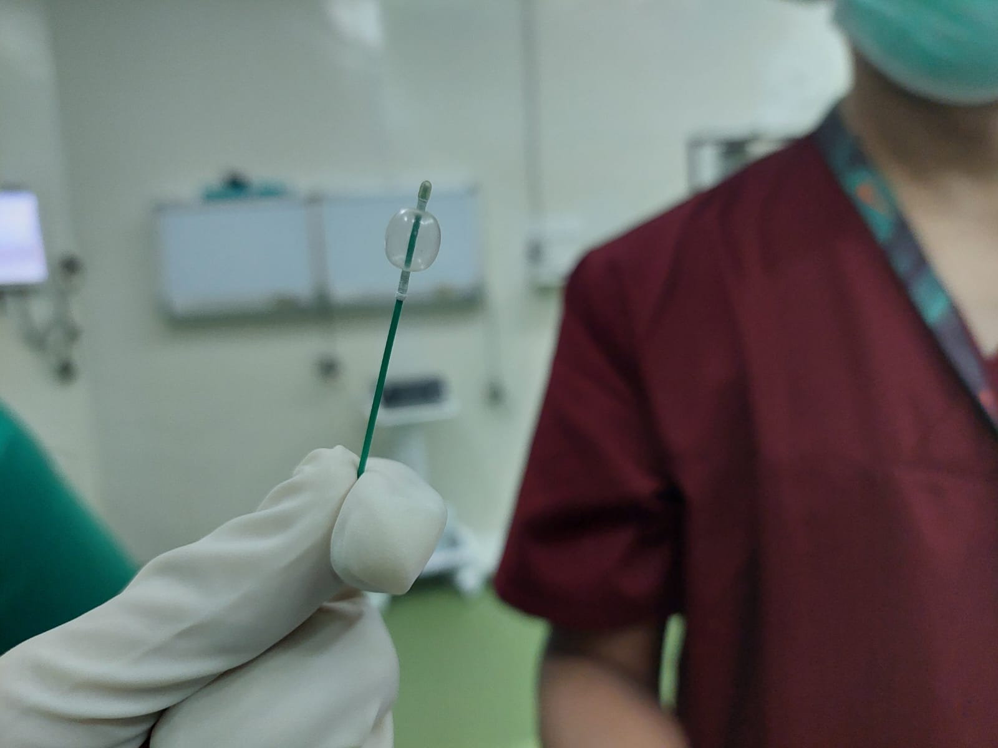
Figure 3. Fogarty Catheter Used On Patients

During the operation process, monitoring is carried out by carrying out maintenance procedures by providing compressed air oxygenation with additional sevoflurane (Coté et al., 2019). Monitoring is carried out with a standard monitor by ensuring EtCO2 is in the range of 30-45cmH2O with oxygen saturation maintained in the range of 96-100%. Completion of VATS takes two hours and is performed in the left lateral decubitus position. The bronchopleural fistula was closed, the bulla was effectively removed, and the chest tube remained intact. After the procedure, the Fogarty catheter is deflated. The patient was placed back supine, the right lung was successfully enlarged, and a lung recruitment procedure was performed (Constantin et al., 2019). After discharge from the operating room, the patient was monitored in the PICU. Two days after surgery, the chest tube was removed, and the patient was discharged on the third day.

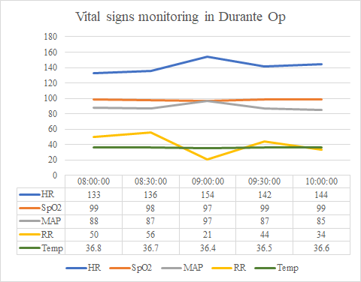
Figure 4. Vital Sign Monitoring During The Operation Procedure

One-lung ventilation (OLV) is a technique used during thoracic surgery, such as lobectomy or pneumonectomy. It requires the isolation of one lung to provide optimal surgical exposure and maintain ventilation (Rakovich et al., 2020). Although OLV is more commonly performed in adults, it is also used in pediatric patients undergoing similar procedures (Lee et al., 2019). One-lung ventilation (OLV) in children is indicated for various thoracic operations, including lung resection, thoracoscopic procedures, repair of congenital heart defects, and corrective surgery for thoracic deformities. The primary goal is to facilitate optimal surgical exposure while maintaining adequate oxygenation and ventilation. Pediatric patients undergoing OLV require careful anesthetic management to ensure smooth induction, maintenance, and recovery from anesthesia (Nasr & DiNardo, 2017). Anesthetic agents should be titrated to minimize cardiovascular depression and maintain hemodynamic stability. Lung isolation is usually performed with DLT or BB guided by fiberoptic bronchoscopy. During OLV, mechanical ventilation is delivered to the ventilated lung, while the airless lung can collapse passively. Ventilator settings should be adjusted to maintain adequate oxygenation and ventilation while minimizing barotrauma and volutrauma (Iyer & Shah, 2016).
Hypoxemia is a common concern during single-lung ventilation, especially in pediatric patients with limited physiologic oxygen reserves (Berg et al., 2019) Strategies to optimize oxygenation include adjusting ventilator settings, increasing FiO2, and positioning the patient to improve ventilation-perfusion compliance. In some cases, selective lung inflation techniques may improve oxygenation and surgical exposure. Continuous monitoring of oxygen saturation, EtCO2, arterial blood gases, and hemodynamic parameters is essential during single-lung ventilation in children. Fiberoptic bronchoscopy may be used periodically to ensure lung isolation, assess lung collapse, and identify airway complications. Complications associated with single-lung ventilation in children include hypoxemia, hypercarbia, lung collapse, bronchial obstruction, and hemodynamic instability. Prompt recognition and treatment of complications are essential to prevent adverse outcomes. Strategies to manage complications may include repositioning the DLT or BB, adjusting ventilator settings, suction bronchoscopy, and conversion to two-lung ventilation if necessary (Nwajuaku et al., 2023).
The Fogarty catheter is a specialized device used in adult patients for selective lung isolation during OLV procedures. Although used less frequently in children compared with DLT or BB, the Fogarty catheter technique can still be used in pediatric patients, especially when DLT or BB is unavailable. The Fogarty catheter technique for OLV procedures in children is indicated for thoracic surgery requiring selective lung isolation, such as lung resection, thoracoscopic procedures, repair of congenital heart defects, and corrective surgery of thoracic deformities. It can be used when DLT or BB is contraindicated or unavailable (Proschek & Vogl, 2016).
Pediatric patients undergoing OLV with a Fogarty catheter require careful anesthetic management to ensure smooth induction, maintenance, and recovery from anesthesia (Ross et al., 2020) Anesthetic agents should be titrated to minimize cardiovascular depression and maintain hemodynamic stability. Lung isolation was confirmed using fiberoptic bronchoscopy to visualize the position of the Fogarty catheter balloon. During single-lung ventilation with a Fogarty catheter, mechanical ventilation is delivered to the ventilated lung, while the unventilated lung can passively collapse. Ventilator settings should be adjusted to maintain adequate oxygenation and ventilation while minimizing barotrauma and volutrauma (Shah et al., 2017).
The authors of this case report modified the way OLV is performed in pediatrics by using a single lumen ETT and a Fogarty embolectomy catheter instead of a BB instead of a video-visual FOB device. The patient was premedicated with ketamine as a cholinergic agent and midazolam as an anxiolysis agent. Induction of anesthesia was performed using atracurium to facilitate intubation. According to the literature, an ETT size of 4.5 is recommended for children aged 2-6 years (Subramanian et al., 2018).
A single-lumen ETT measuring 4.5 was used in this patient. This selection also considered the largest ETT size that could be inserted in the patient to provide more space for ventilation and installation of an intraluminal Forgaty catheter to isolate the right lung. Based on CT-scan-guided measurements, the forgotten catheter was inserted through a 36 cm long L-connector according to the results of calculations and measurements carried out with CT-scan guidance (Subramanian et al., 2018).
The fact that the tip of the FEC in this case report does not have a channel, making it impossible to suction, oxygenate the closed lung, and prevent edema and damage to the pulmonary mucosa, is one of the disadvantages of its use as a replacement for BB. Using smaller single-lumen ETTs for intubation also has disadvantages, as it can hinder overall airway control. In addition, the size of the lung lobes is not the same as the bronchi due to the use of single-lumen ETT, making it difficult to separate specific lung lobes.

CONCLUSION
An in-depth understanding of pediatric and thoracic anesthesia basics is necessary for safe and efficient anesthesia care during pediatric thoracic surgery. In addition, there are particular dangers and difficulties associated with thoracic surgery, necessitating caution during the perioperative phase. To safely perform OLV treatment in pediatric patients undergoing thoracoscopic procedures, combining anatomical knowledge with the ability to measure and modify existing equipment depending on radiological results may be useful.

BIBLIOGRAPHY
Behera, B. K., Misra, S., Mohanty, M. K., & Tripathy, B. B. (2022). Use of Fogarty catheter as bronchial blocker for lung isolation in children undergoing thoracic surgery: A single centre experience of 15 cases. Annals of Cardiac Anaesthesia, 25(2), 148–152.
Berg, S., Bittner, E. A., Berra, L., Kacmarek, R. M., & Sonny, A. (2019). Independent lung ventilation: implementation strategies and review of literature. World Journal of Critical Care Medicine, 8(4), 49.
Boisen, M. L., Fernando, R. J., Alfaras-Melainis, K., Hoffmann, P. J., Kolarczyk, L. M., Teeter, E., Schisler, T., Ritchie, P. J., La Colla, L., & Rao, V. K. (2022). The year in thoracic anesthesia: Selected highlights from 2021. Journal of Cardiothoracic and Vascular Anesthesia, 36(12), 4252–4265.
Constantin, J.-M., Jabaudon, M., Lefrant, J.-Y., Jaber, S., Quenot, J.-P., Langeron, O., Ferrandière, M., Grelon, F., Seguin, P., & Ichai, C. (2019). Personalised mechanical ventilation tailored to lung morphology versus low positive end-expiratory pressure for patients with acute respiratory distress syndrome in France (the LIVE study): a multicentre, single-blind, randomised controlled trial. The Lancet Respiratory Medicine, 7(10), 870–880.
Coté, C. J., Wilson, S., Pediatrics, A. A. of, & Dentistry, A. A. of P. (2019). Guidelines for monitoring and management of pediatric patients before, during, and after sedation for diagnostic and therapeutic procedures. Pediatrics, 143(6).
Iyer, S. S., & Shah, J. (2016). Mechanical Ventilation. Clinical Pathways in Emergency Medicine: Volume I, 191–206.
Kiblawi, R., Zoeller, C., Zanini, A., Ure, B. M., Dingemann, J., Kuebler, J. F., & Schukfeh, N. (2021). Video-assisted thoracoscopic or conventional thoracic surgery in infants and children: current evidence. European Journal of Pediatric Surgery, 31(01), 54–64.
Lee, J.-H., Bae, J., Jang, Y.-E., Kim, E.-H., Kim, H.-S., & Kim, J.-T. (2019). Lung protective ventilation during pulmonary resection in children: a prospective, single-centre, randomised controlled trial. British Journal of Anaesthesia, 122(5), 692–701.
Merchant, R. N., Chima, N., Ljungqvist, O., & Kok, J. N. J. (2020). Preoperative fasting practices across three Anesthesia societies: Survey of practitioners. JMIR Perioperative Medicine, 3(1), e15905.
Murray-Torres, T. M., Winch, P. D., Naguib, A. N., & Tobias, J. D. (2021). Anesthesia for thoracic surgery in infants and children. Saudi Journal of Anaesthesia, 15(3), 283–299.
Nasr, V. G., & DiNardo, J. A. (2017). The pediatric cardiac anesthesia handbook. John Wiley & Sons.
Nwajuaku, P., Hegland, D. L., & Goldstein, J. C. (2023). One-Lung Ventilation. Emergency Anesthesia Procedures, 33.
Proschek, P., & Vogl, T. J. (2016). Chest and mediastinum. Diagnostic and Interventional Radiology, 479–587.
RAHMAN, S. M. T., MIAb, M. M. R., HOSSAIN, M., ISLAM, K. S., KIBRIA, A. A., BISWAS, M., RAHIM, A., HOSSAIN, M., ISLAM, M. N., & RAZZAQUE, A. K. M. (2023). Video-Assisted Thoracoscopic Surgery (VATS) in the Treatment of Pulmonary Bulla. Journal of Bangladesh College of Physicians and Surgeons, 41(4).
Rakovich, G., Urbanowicz, R., Issa, R., & Wang, H. T. (2020). Minimizing the risk of aerosol contamination during elective lung resection surgery. Annals of Surgery, 272(2), e125–e128.
Ross, F., McFadyen, G., Budac, S., Martin, L. D., & Richards, M. (2020). Anesthesia for Thoracic Surgery. Gregory’s Pediatric Anesthesia, 607–625.
Shah, A. A., Kettle, P. B., & Niven, A. S. (2017). Ventilator management: a practical approach to respiratory failure in combat casualties. Front Line Surgery: A Practical Approach, 631–646.
Subramanian, S., Nishtala, M., Ramavakoda, C. Y., & Kothari, G. (2018). Predicting endotracheal tube size from length: evaluation of the Broselow tape in Indian children. Journal of Anaesthesiology Clinical Pharmacology, 34(1), 73–77.
Templeton, T. W., Piccioni, F., & Chatterjee, D. (2021). An update on one-lung ventilation in children. Anesthesia & Analgesia, 132(5), 1389–1399.
Tognon, C., Pulvirenti, R., Pizzi, S., Zuliani, M., Cortese, G., Esposito, C., & Gamba, P. (2022). Lung ultrasound to assess one lung ventilation: a pediatric case series. Journal of Laparoendoscopic & Advanced Surgical Techniques, 32(5), 566–570.
Yao, W., Li, M., Zhang, C., & Luo, A. (2022). Recent advances in videolaryngoscopy for one-lung ventilation in thoracic anesthesia: a narrative review. Frontiers in Medicine, 9, 822646.

Copyright holder:
I Putu Kurniyanta, I Made Pasek Budiadnyana, Tjokorda Gde Agung Senapathi, Kadek Agus Heryana Putra, Otniel Adrians Labobar, I Wayan Sudarma (2024)
First publication right:
Asian Journal of Engineering, Social and Health (AJESH)
This article is licensed under:

