Beyond Project Status: System Shift as a Structural Diagnostic Framework for Predicting Delay, Stagnation, and Adaptive Progression in Pharmaceutical Development Portfolios

Raymond Rubianto Tjandrawinata
Universitas Katolik Indonesia Atma Jaya, Indonesia
Email: raytjan@yahoo.com

Keywords: | ABSTRACT
System Shift; pharmaceutical development; project stagnation; bottlenecks; organizational learning | The pharmaceutical industry continues to face significant challenges in research and development (R&D) productivity, characterized by increasing development costs, extended timelines, and high rates of project delay and stagnation. Although project status classifications are widely used to monitor development progress, they often fail to explain the structural factors that cause projects to become stalled. This study aims to evaluate the System Shift framework as a structural diagnostic model for predicting delay, stagnation, adaptive progression, and success in pharmaceutical development portfolios. An exploratory empirical-methodological approach was employed using data from a pharmaceutical development portfolio consisting of 112 projects, from which 41 project-level cases were selected and coded. The framework operationalized seven dimensions: System Condition, Domain Lock, Actor Complexity, Chokepoint Severity, Position Quality, Strategy Quality, and Feedback Maturity. Data were analyzed through descriptive statistics, correlation analysis, regression models, logistic models, and cluster analysis. The findings reveal that Chokepoint Severity is the strongest predictor of project delay (r = 0.932; R² = 0.868), while Feedback Maturity and Strategy Quality significantly enhance progression and success. Furthermore, the System Shift Risk Score demonstrated superior predictive performance compared to traditional status-based classifications. The study concludes that System Shift provides a promising diagnostic framework for identifying structural constraints and adaptive capacities, thereby supporting more effective portfolio governance, decision-making, and organizational learning in pharmaceutical development environments.

INTRODUCTION
The pharmaceutical industry has long faced a persistent productivity challenge in research and development, marked by rising development cost, high attrition, declining output efficiency, and the difficulty of translating scientific effort into successful development outcomes (Paul et al., 2010; Pammolli et al., 2011; Cook et al., 2014; Morgan et al., 2018). This concern has generated a large body of work on decision quality, portfolio governance, innovation portfolio management, and organizational learning in drug development and project-based organizations (Jekunen, 2014; Kock & Gemünden, 2016). Yet one practical problem remains undiagnosed: why do some development projects become structurally stuck even when they remain administratively visible, technically active, and formally reviewed?
In many development organizations, projects are classified by status labels such as lab trial, procurement, pilot scale, bioequivalence preparation, registration preparation, exhibit batch, or hold (Desai dan Patel 2021; Al-Shimari et al. 2023). These labels are useful for coordination, but not for explanation. A project can be in a lab trial because it is progressing through expected experimentation, or because it is trapped in unresolved formulation, analytical, material, or equipment constraints. A project can be on hold because of a clear strategic decision or because decision rights, technical evidence, and resource availability no longer align (Shenhar dan Holzmann 2017). In this sense, status tells the observer where the project is, but not why the project is unable to move.
The empirical setting motivating this paper is a pharmaceutical development portfolio comprising 112 pipeline projects as of May 2026, including 78 new-product-development cases and 34 existing-product-improvement cases. The portfolio profile shows a heavy concentration in Lab Trial, with additional concentrations in Hold, Exhibit Batch, Procurement, Queuing, Pilot BE Study, Done T0, and Devpro Preparation. Such a pattern suggests a portfolio that is not merely large but structurally congested. It also shows why a conventional status dashboard may be insufficient: the portfolio requires not only tracking but also diagnosis.
The same portfolio material contains concrete examples of technical and coordination constraints. An injectable 1% infusion project showed dissolved-oxygen issues, capping mismatch, and visible-particle rejection. Several solid oncology projects were affected by dissolution similarity issues, comparator availability, BE failures, API source decisions, assay issues, and supplier warnings. Parenteral-nutrition projects incompletely exhibited analytical-method dependencies, raw-material verification gaps, unfinished equipment qualification, and costly analytical logistics. These examples are not isolated anecdotes. They are empirical signals of a system in which movement depends on the interaction between technical constraints, coordination density, resource access, and learning capacity.
This concern has been addressed through work on pharmaceutical R&D productivity, portfolio decision quality, innovation portfolio governance, and organizational learning across project-based settings (Jekunen, 2014; Kock & Gemünden, 2016).
This paper proposes System Shift as a structural diagnostic framework for reading such conditions, building on the author’s broader work on systems in motion, pharmaceutical political economy, and AI-enabled decision architecture in pharmacy and organizational transformation (Tjandrawinata, 2026a; Tjandrawinata, 2026b; Tjandrawinata, 2026c). Its central proposition is that project delay and stagnation emerge from the interaction between pressure-side variables and adaptive-side variables. The pressure side consists of System Condition, Domain Lock, Actor Complexity, and Chokepoint Severity. The adaptive side consists of Position Quality, Strategy Quality, and Feedback Maturity. The framework does not assume that delay is caused by a single actor or a single decision. Instead, it treats delay as a system-state phenomenon: movement becomes difficult when structural pressure accumulates faster than the system’s capacity to position, respond, learn, and reconfigure.
Previous studies have extensively examined pharmaceutical R&D productivity and portfolio management from various perspectives. Paul et al. (2010) highlighted the productivity crisis in pharmaceutical innovation and emphasized the need for improved decision-making processes. Pammolli et al. (2011) further demonstrated that declining R&D productivity is associated with increasing development complexity and regulatory burdens. Similarly, Cooper et al. (1999; 2001) and Jekunen (2014) investigated portfolio management practices and decision quality in pharmaceutical environments, concluding that strategic resource allocation significantly influences project outcomes. More recently, Morgan et al. (2018) reported that multidimensional portfolio evaluation frameworks can improve development performance by integrating scientific, commercial, and organizational considerations.
Although these studies provide valuable insights into pharmaceutical portfolio governance, they primarily focus on project selection, prioritization, resource allocation, and strategic decision-making. Limited attention has been given to understanding why projects become structurally trapped despite remaining active within organizational systems. Existing approaches generally assess project status, performance indicators, or stage-gate compliance without explicitly diagnosing the interactions among technical constraints, coordination challenges, organizational learning processes, and adaptive capacities. As a result, the mechanisms that transform routine project challenges into persistent stagnation remain insufficiently understood.
This limitation reveals a significant research gap in the pharmaceutical management literature. While previous studies explain how projects should be selected and managed, fewer studies provide diagnostic frameworks capable of identifying structural conditions that generate delays and stagnation during project execution. Moreover, existing project-status classifications tend to describe observable conditions rather than explain underlying causal structures. Therefore, there is a need for a more comprehensive framework that captures both pressure-generating factors and adaptive-response mechanisms within pharmaceutical development portfolios.
Addressing this gap is increasingly urgent as pharmaceutical organizations operate in highly dynamic and uncertain environments characterized by technological change, supply chain disruptions, regulatory complexity, and growing competitive pressures. Delays in pharmaceutical development not only affect organizational performance but may also postpone patient access to potentially life-saving treatments. Consequently, identifying reliable indicators of stagnation and adaptive progression has become essential for enhancing portfolio governance, improving organizational learning, and increasing the efficiency of innovation processes within the pharmaceutical sector.
To address these challenges, this study introduces the System Shift framework as a structural diagnostic approach for understanding movement, delay, stagnation, and adaptive progression within pharmaceutical development portfolios. Unlike traditional project-status models, System Shift conceptualizes project outcomes as the result of interactions between pressure-side dimensions, including System Condition, Domain Lock, Actor Complexity, and Chokepoint Severity, and adaptive-side dimensions, including Position Quality, Strategy Quality, and Feedback Maturity. This perspective allows researchers and practitioners to move beyond descriptive classifications toward a deeper understanding of structural dynamics affecting project performance.
The novelty of this research lies in its integration of complex systems thinking with measurable diagnostic indicators that capture both structural constraints and adaptive capacities. Furthermore, the study empirically evaluates the predictive capability of the System Shift framework using project-level evidence from pharmaceutical development portfolios. By examining the relationships between structural risk factors, adaptive mechanisms, and project outcomes, this research offers a new perspective on portfolio diagnosis that extends beyond conventional stage-gate and status-monitoring approaches.
Accordingly, the purpose of this study is to examine the validity of the System Shift framework as a structural diagnostic model for predicting delay, stagnation, progression, and success within pharmaceutical development portfolios. The research contributes theoretically by expanding the literature on pharmaceutical portfolio management through a systems-based diagnostic perspective and contributes practically by providing managers with a tool for identifying bottlenecks, prioritizing interventions, and improving portfolio governance. Ultimately, the findings are expected to support more effective decision-making, strengthen organizational learning, reduce project stagnation, and enhance innovation performance within pharmaceutical development systems.

METHOD

Research design and empirical setting
The study used an exploratory empirical-methodological design. It is exploratory because the coding architecture is newly proposed, the sample is limited, and the data come from a single organizational setting. It is empirical because the framework is tested against observable project outcomes rather than defended only conceptually. It is methodological because the main contribution is the development and early validation of a diagnostic measurement architecture.
The empirical setting is an internal pharmaceutical development portfolio update dated May 2026. The source material documents a 112-project pipeline with substantial concentrations in Lab Trial, Hold, Procurement, Exhibit Batch, Queuing, Pilot BE Study, Done T0, and Devpro Preparation. From this broader portfolio, 41 project-level cases with sufficient descriptive evidence were coded into the pilot validation dataset. The analytic file included SC, DL, AC, CP, POS, STR, FB, System_Shift_Risk_Score, Weighted_Risk_Score, Delay_Months, Progression, Success, and Outcome_Status.

Coding rubric and variables
Each System Shift component was scored on a 1-5 diagnostic scale. Outcome variables were Delay_Months, Progression (0/1), Success (0/1), and Outcome_Status. The coding was based on available slide evidence and is therefore treated as a first-pass diagnostic coding appropriate for exploratory validation, not as a final audited dataset. This treatment is consistent with early-stage construct validation, where conceptual clarity, indicator specification, and alignment between the construct and its measurement model are more important than premature claims of final measurement certainty (MacKenzie et al., 2011). All coding was performed by a single coder; inter-rater reliability assessment is planned for future validation phases.
Table 1. Coding Architecture for The Seven System Shift Components
Component | Definition | Scale anchor | Expected sign if framework is valid
System Condition | Baseline system pressure and uncertainty | 1 = stable; 5 = very high pressure | Positive with delay/stagnation
Domain Lock | Degree of structural lock-in | 1 = flexible; 5 = locked | Positive with delay/stagnation
Actor Complexity | Coordination and actor density | 1 = simple; 5 = complex | Positive with delay/stagnation
Chokepoint Severity | Intensity of active bottleneck | 1 = minor; 5 = critical stop | Strongest positive predictor of delay/stagnation
Position Quality | Strategic positioning in relation to the system | 1 = reactive; 5 = anticipatory | Negative with delay; positive with success
Strategy Quality | Quality of response or intervention | 1 = weak; 5 = directly addresses chokepoint | Negative with delay; positive with success
Feedback Maturity | Strength of iterative learning and correction | 1 = absent; 5 = mature evidence-driven loop | Negative with delay; positive with success
The primary composite index was defined as:
System_Shift_Risk_Score = SC + DL + AC + CP - POS - STR - FB

Statistical analysis plan
The empirical testing strategy began with descriptive statistics and correlation analysis, followed by criterion-related and predictive validation tests. The analysis included simple linear regression of CP on Delay_Months, simple linear regression of CP on Stagnation where Stagnation = 1 - Progression, logistic models using FB and STR to predict Success and Progression, comparison of the System_Shift_Risk_Score model against a status-only model, feature-importance inspection, and three-cluster analysis.
A formal EFA/CFA/SEM test was not treated as decisive in this version because the sample size is small and the framework is better understood at this stage as a diagnostic composite architecture rather than a reflective latent-variable model requiring full factor-analytic confirmation (Wolf et al., 2013). The sample size is small, several predictors are strongly correlated, and, at this stage, the framework is better understood as a diagnostic composite architecture rather than a reflective latent-variable model. Given the small single-site sample and strong intercorrelations among several predictors, the present study prioritizes exploratory criterion validity, predictive comparison, and state-based clustering over formal latent-variable confirmation, since multicollinearity and correlated predictor structures may distort coefficient interpretation and variable-importance estimates.

RESULTS AND DISCUSSION

Descriptive statistics
The descriptive profile of the sample indicates a portfolio under meaningful strain but not total collapse. Mean values were SC = 3.439, DL = 3.317, AC = 3.659, CP = 3.463, POS = 3.171, STR = 3.463, FB = 2.585, Delay_Months = 3.244, Progression = 0.488, and Success = 0.390. This configuration is analytically favorable for exploratory validation because it contains enough variation to distinguish stalled, slowly moving, progressing, and successful cases.
Table 2. Descriptive Statistics for The Coded Dataset
Variable | Mean | SD | Min | Max
SC | 3.439 | 1.097 | 2.000 | 5.000
DL | 3.317 | 1.128 | 2.000 | 5.000
AC | 3.659 | 0.728 | 3.000 | 5.000
CP | 3.463 | 1.120 | 2.000 | 5.000
POS | 3.171 | 0.803 | 2.000 | 4.000
STR | 3.463 | 0.596 | 2.000 | 4.000
FB | 2.585 | 0.741 | 1.000 | 4.000
System_Shift_Risk_Score | 4.659 | 5.606 | -3.000 | 14.000
Delay_Months | 3.244 | 2.188 | 1.000 | 8.000
Progression | 0.488 | 0.506 | 0.000 | 1.000
Success | 0.390 | 0.494 | 0.000 | 1.000

Correlation structure
The correlation structure strongly supports the theoretical architecture. On the pressure side, CP was strongly associated with Delay_Months (r = 0.932) and negatively associated with Progression (r = -0.806) and Success (r = -0.742). On the adaptive side, FB correlated negatively with Delay_Months (r = -0.769) and positively with Progression (r = 0.820) and Success (r = 0.727). STR showed the same directional pattern with Delay_Months (r = -0.645), Progression (r = 0.724), and Success (r = 0.730). The aggregate System_Shift_Risk_Score was even stronger, correlating 0.954 with Delay_Months, -0.856 with Progression, and -0.790 with Success.
Figure 1 visualizes the full correlation structure of the System Shift variables and outcomes. A clear two-pole pattern is evident. The pressure-side variables, namely System Condition, Domain Lock, Actor Complexity, and Chokepoint Severity, move together and are positively associated with Delay_Months and the composite System_Shift_Risk_Score. By contrast, the adaptive-side variables, namely Position Quality, Strategy Quality, and Feedback Maturity, move in the opposite direction and align positively with Progression and Success. This pattern is theoretically consistent with the framework’s central proposition that project stagnation arises from the interaction between structural pressure and adaptive response capacity. At the same time, the high correlations among several pressure-side predictors require methodological caution: the current study supports exploratory criterion validity more strongly than independent latent-dimensional validation.
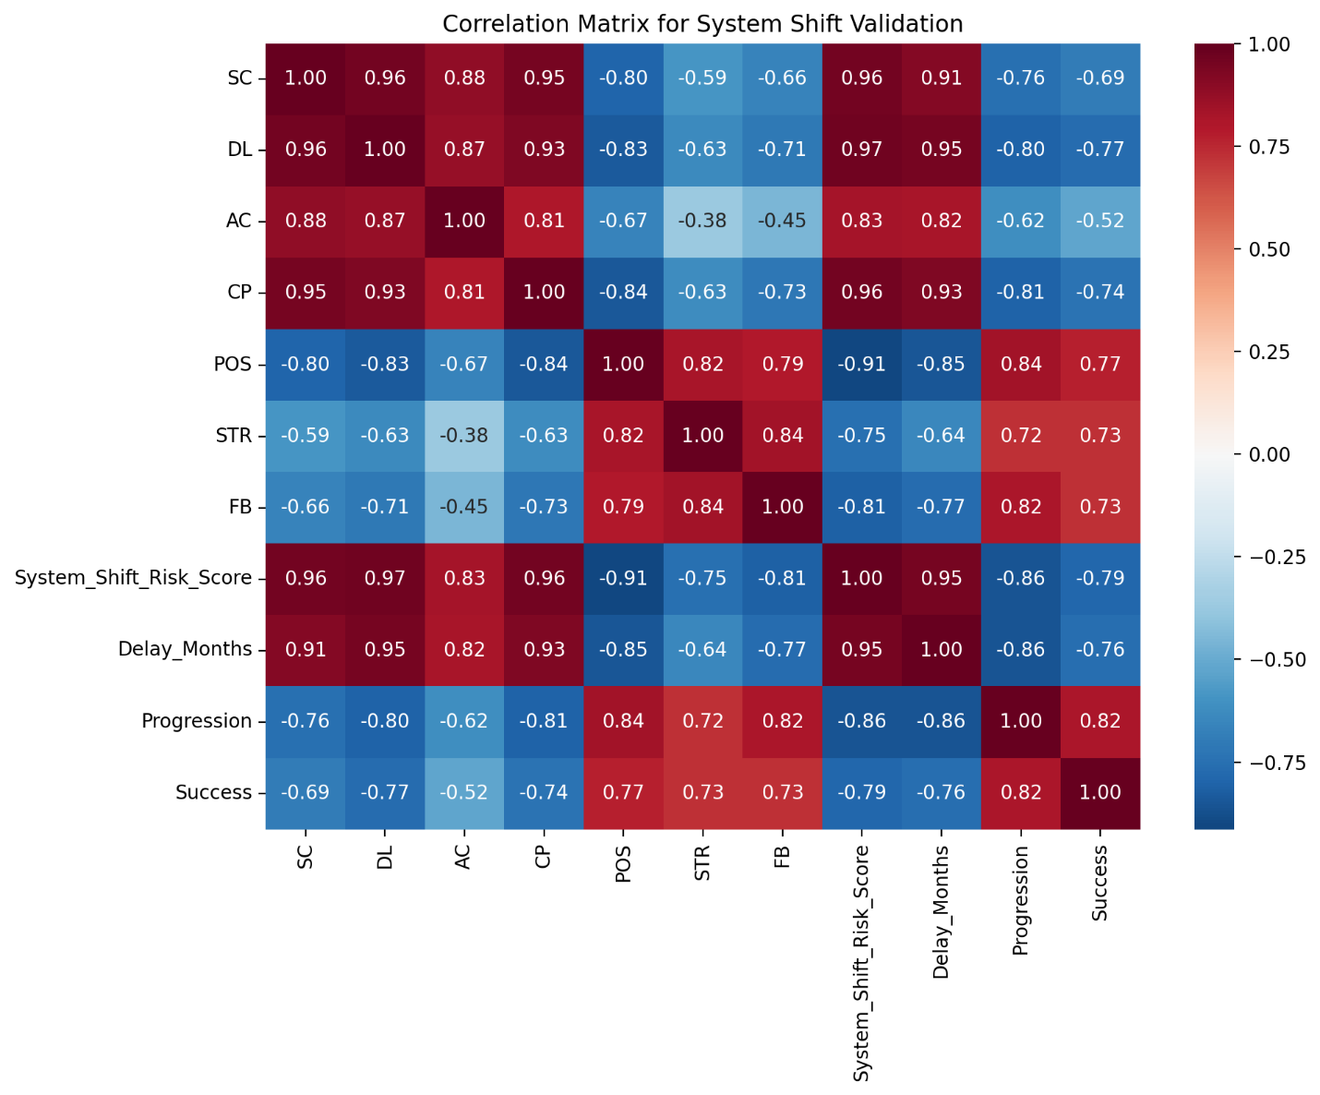
Figure 1. Correlation Matrix for The System Shift Validation Sample
The figure shows strong positive associations among pressure-side variables (SC, DL, AC, CP, and System_Shift_Risk_Score), inverse associations between pressure-side and adaptive-side variables (POS, STR, FB), and the expected alignment of adaptive-side variables with Progression and Success.

Table 3. Key Correlations between System Shift Variables and Outcomes
Predictor | Delay_Months | Progression | Success
SC | 0.913 | -0.756 | -0.694
DL | 0.950 | -0.803 | -0.766
AC | 0.820 | -0.622 | -0.524
CP | 0.932 | -0.806 | -0.742
POS | -0.849 | 0.836 | 0.773
STR | -0.645 | 0.724 | 0.730
FB | -0.769 | 0.820 | 0.727
System_Shift_Risk_Score | 0.954 | -0.856 | -0.790

Linear regression of delay and stagnation
The strongest empirical result is the simple linear model of CP predicting Delay_Months. The model produced slope = 1.8202, intercept = -3.0603, R² = 0.8682, Pearson r = 0.9318, and p approximately 0. Interpreted substantively, each one-point increase in Chokepoint Severity was associated with approximately 1.82 additional months of delay. For an exploratory organizational dataset, this is a very large effect and gives direct support to the proposition that active chokepoints are central engines of delay.
Figure 2 depicts the relationship between Chokepoint Severity and Delay_Months. The fitted line and the relatively narrow spread around it provide visual support for the strong bivariate association. In substantive terms, the figure makes the paper’s core claim visible: delay in this portfolio is not random administrative drift, but is concentrated around the severity of active bottlenecks. The corresponding stagnation model was also strong. With Stagnation defined as 1 - Progression, the CP to Stagnation regression yielded slope = 0.3639, intercept = -0.7483, R² = 0.6490, Pearson r = 0.8056, and p approximately 0. This indicates that chokepoints do not merely lengthen project duration; they also alter the movement state of the system by increasing the probability that the project becomes functionally stuck.
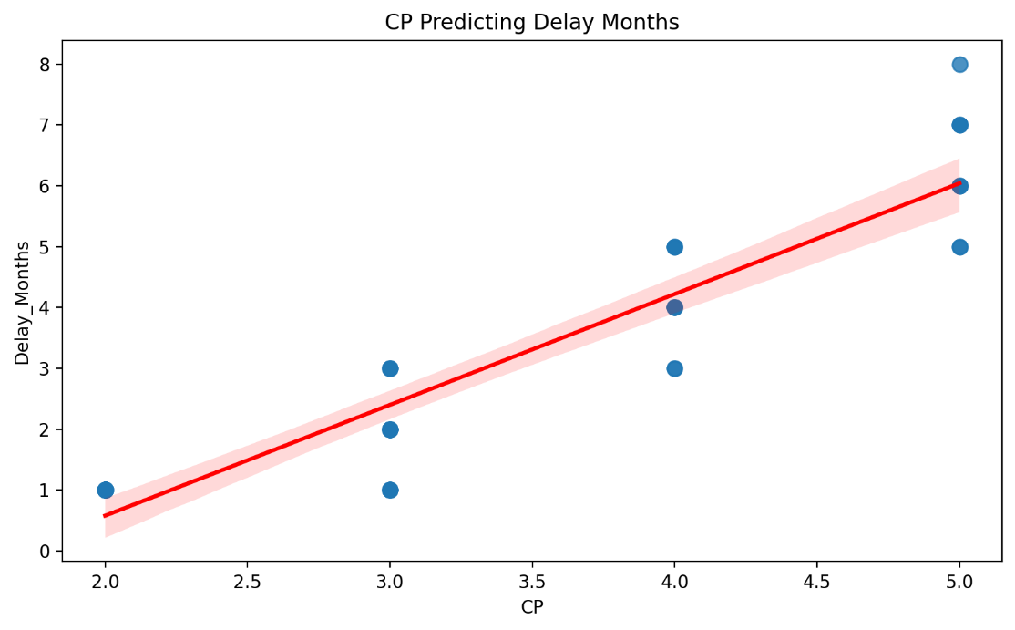
Figure 2. Chokepoint Severity Predicting Delay_Months
The scatterplot with fitted regression line shows a strong positive relationship between active bottleneck severity and project delay. The figure visually supports the reported regression result that higher chokepoint severity is associated with longer delay

Table 4. Linear Regression Results for Delay and Stagnation
Model | Slope | Intercept | r | R² | p-value
CP -> Delay_Months | 1.8202 | -3.0603 | 0.9318 | 0.8682 | ~0
CP -> Stagnation | 0.3639 | -0.7483 | 0.8056 | 0.6490 | ~0

Logistic models for success and progression
The adaptive side of the framework is also supported. In the logistic model predicting Success, the coefficients were FB = 1.6833 and STR = 1.6163, with apparent accuracy = 0.9024 and log loss = 0.2863. Exponentiating these coefficients gives approximate odds ratios of 5.38 for FB and 5.03 for STR. Within the limits of an exploratory model, this indicates that stronger feedback maturity and strategy quality were associated with substantially higher odds of success.
The Progression model is even more revealing. The coefficients were FB = 2.3026 and STR = 1.0696, with apparent accuracy = 0.9512 and log loss = 0.2424. Translated into odds ratios, these coefficients imply approximately 10.00 for FB and 2.91 for STR. The theoretical implication is important: feedback maturity appears even more decisive for keeping projects moving than for producing success per se. This supports the interpretation of feedback as the key adaptive mechanism rather than a secondary management variable.
Table 5. Logistic Regression Results for Success and Progression
Outcome | Predictor | Coefficient | Approx. odds ratio | Apparent accuracy | Log loss
Success | FB | 1.6833 | 5.38 | 0.9024 | 0.2863
Success | STR | 1.6163 | 5.03 | 0.9024 | 0.2863
Progression | FB | 2.3026 | 10.00 | 0.9512 | 0.2424
Progression | STR | 1.0696 | 2.91 | 0.9512 | 0.2424

Comparative model performance and feature importance
One of the most important validation tests is whether the System Shift composite adds value beyond conventional status labels. For Delay_Months, the risk-score model achieved R² = 0.9111, whereas the status-only model achieved R² = 0.7074. For Success, the risk-score model achieved AUC = 0.9700 compared with AUC = 0.9575 for status alone. For Progression, the comparison was AUC = 0.9869 for the risk-score model versus 0.9762 for the status-only model. This is one of the clearest arguments for the manuscript’s novelty: System Shift is not merely a relabeling of existing project status categories; it appears to provide incremental diagnostic validity.
Figure 3 summarizes feature importance across Delay, Success, and Progression. The dominant role of System_Shift_Risk_Score is visually clear, especially for Delay, while Feedback Maturity emerges as particularly consequential for Progression. This pattern reinforces the interpretation that cumulative structural risk explains delay most strongly, whereas adaptive learning capacity is critical for maintaining movement through the portfolio. However, the feature-importance results should be read as exploratory rather than definitive, because the predictors are strongly correlated. Under correlated-predictor conditions, variable-importance rankings can be unstable or difficult to interpret without additional robustness checks, particularly when predictors share overlapping structural information within a small exploratory dataset.

Table 6. Model Comparison between System Shift Risk Score and Status-Only Model
Outcome | System Shift model | Status-only model | Better model
Delay_Months | R² = 0.9111 | R² = 0.7074 | System Shift
Success | AUC = 0.9700 | AUC = 0.9575 | System Shift
Progression | AUC = 0.9869 | AUC = 0.9762 | System Shift

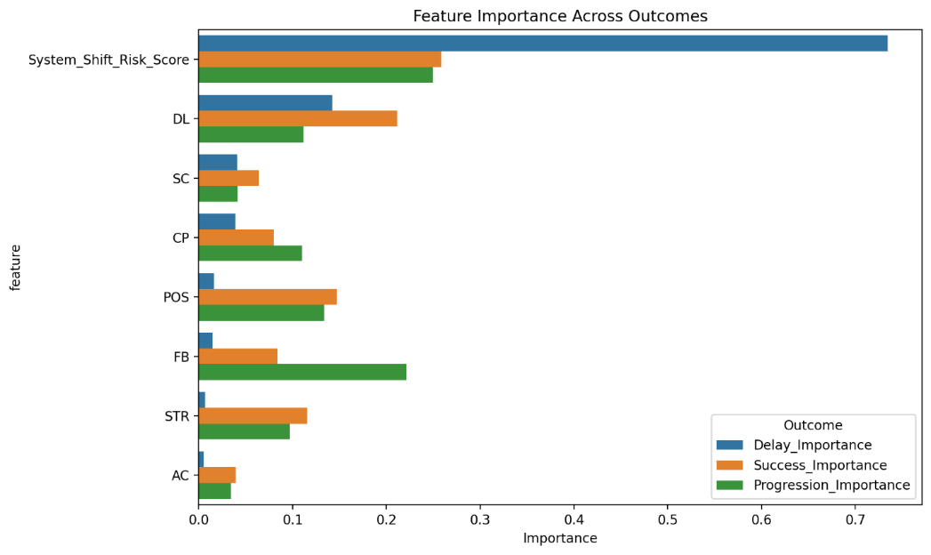
Figure 3. Feature Importance Across Delay, Success, and Progression
The chart shows that System_Shift_Risk_Score is the most prominent predictor overall, especially for Delay, while Feedback Maturity becomes comparatively more important for Progression. Because several predictors are highly correlated, these feature-importance estimates should be interpreted as exploratory model-inspection results.

Table 7. Feature Importance Across Outcomes
Feature | Delay importance | Success importance | Progression importance
System_Shift_Risk_Score | 0.7345 | 0.2586 | 0.2497
DL | 0.1424 | 0.2116 | 0.1118
SC | lower | lower | lower
CP | lower | 0.0800 | 0.1101
POS | lower | 0.1472 | 0.1338
FB | lower | 0.0842 | 0.2216
STR | lower | 0.1154 | 0.0970
AC | lower | lower | lower

Risk score and cluster structure
The risk score is also substantively meaningful as a portfolio discriminator. In the coded dataset, the score ranges from -3 to 14, with a mean of 4.659. That spread is useful because it separates relatively adaptive and structurally risky cases within the same portfolio. A diagnostic score is valuable only if it can stratify cases into different operating conditions; here, the System_Shift_Risk_Score does precisely that.
Cluster analysis produced three highly interpretable groups. Cluster 0 contained 17 cases with CP = 2.412, POS = 4.000, STR = 4.000, FB = 3.235, Risk Score = -1.000, Delay_Months = 1.176, Progression = 1.000, and Success = 0.882; this is the adaptive low-risk cluster. Cluster 1 contained 18 cases with CP = 4.556, POS = 2.444, STR = 3.111, FB = 2.056, Risk Score = 10.222, Delay_Months = 5.389, Progression = 0.056, and Success = 0.056; this is clearly the high-chokepoint stagnant cluster. Cluster 2 contained 6 cases with CP = 3.167, POS = 3.000, STR = 3.000, FB = 2.333, Risk Score = 4.000, Delay_Months = 2.667, Progression = 0.333, and Success = 0.000; this is the transitional cluster.
Figure 4 integrates risk score, delay, cluster membership, and success marking in one display. The cases separate into three structurally meaningful regions rather than forming a single undifferentiated cloud. Low-risk cases occupy the lower-left region and coincide with lower delay and more favorable outcomes; high-risk cases concentrate in the upper-right region and align with long delay and failure; transitional cases occupy the middle zone. This state-based visualization strengthens the framework’s theoretical claim that portfolios contain adaptive, stagnant, and transitional conditions rather than merely binary outcomes.

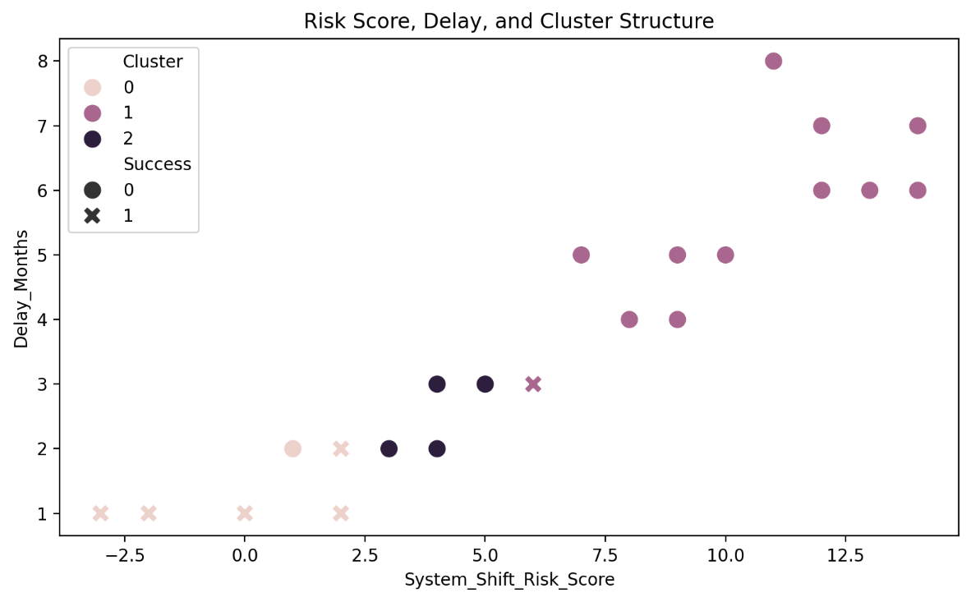
Figure 4. Risk Score, Delay, and Cluster Structure
Cases separate into low-risk adaptive, high-risk stagnant, and intermediate transitional regions. Marker shape indicates success, while color denotes cluster membership. The figure visually supports the argument that System Shift distinguishes structural states of portfolio movement rather than only success/failure outcomes.

Table 8. Cluster Centroids From The Exploratory Analysis
Cluster | n | CP | POS | STR | FB | Risk Score | Delay_Months | Progression | Success | Interpretation
0 | 17 | 2.412 | 4.000 | 4.000 | 3.235 | -1.000 | 1.176 | 1.000 | 0.882 | Low-risk adaptive
1 | 18 | 4.556 | 2.444 | 3.111 | 2.056 | 10.222 | 5.389 | 0.056 | 0.056 | High-chokepoint stagnant
2 | 6 | 3.167 | 3.000 | 3.000 | 2.333 | 4.000 | 2.667 | 0.333 | 0.000 | Transitional

The first major finding is that chokepoints are structural rather than incidental. The empirical strength of the CP-to-Delay_Months relationship suggests that project stagnation in this portfolio is not well understood as generic delay noise. It is better understood as a system being held by one or more active constraints. This interpretation is reinforced by source examples from infusion, oncology, and parenteral nutrition projects, where the observed problems were specific technical, analytical, material, or coordination blockages rather than abstract management labels.
The second major finding is that feedback is the operative mechanism of adaptive movement. Feedback Maturity was strongly associated with both Success and Progression, and was particularly powerful for Progression. In practical terms, Strategy Quality matters, but its effect is amplified when the system can monitor what happens, detect mismatches quickly, and revise action. This supports the view that learning is not a peripheral process in development portfolios. It is a core movement mechanism.
The third major finding is that the System_Shift_Risk_Score adds diagnostic value beyond status-only labeling. This is the manuscript’s most important publishing argument. Administrative classifiers are useful but limited. The present results make that limitation observable: the risk-based model systematically outperformed a simpler status model. System Shift therefore operationalizes a deeper structural concern: a portfolio must be read not only by location in the process, but by the configuration of pressure, lock-in, chokepoints, position, strategy, and feedback.
The fourth major finding is that the case set naturally divides into adaptive, stagnant, and transitional regimes. This moves the framework beyond linear regression into system-state diagnosis. In portfolio-governance terms, different states imply different interventions. Adaptive cases should be protected and accelerated. Stagnant cases require chokepoint removal, re-scoping, or escalation. Transitional cases require intensified feedback and strategic redesign before they drift into the stagnant regime.
The paper contributes to pharmaceutical management scholarship by offering a diagnostic complement to existing productivity and portfolio frameworks. Much of the pharmaceutical R&D literature emphasizes disciplined decision criteria, scientific quality, candidate selection, and portfolio prioritization. System Shift addresses a different but related problem: how to diagnose structural stagnation inside a development portfolio after projects are already in motion.

Practical and Managerial Implications
For portfolio leaders, the practical implication is direct: project review should move beyond status reporting toward structural diagnosis. Instead of asking only whether a project is in lab trial, procurement, pilot scale, or hold, the portfolio review should ask what the active chokepoint is, whether it is technical, material, analytical, regulatory, resource-based, or coordination-based, and whether the current intervention actually touches that chokepoint.
The System Shift score can also support triage. Cases with low risk and strong feedback can be accelerated (Gu et al. 2020; Padala 2023). Cases with high chokepoint severity and weak feedback need immediate structural intervention. Transitional cases are particularly important because they may still be recoverable. In those cases, better feedback loops and targeted strategy may prevent drift into long-term stagnation.
The framework can therefore function as a portfolio diagnostic dashboard, a training tool for cross-functional teams, and a governance mechanism for escalation. Its value lies not in replacing expert judgment, but in making expert judgment more systematic, comparable, and auditable.

Limitations and Future Research
The study has important limitations. First, the sample consists of 41 coded cases, which is adequate for exploratory pilot validation but not for universal validation. Second, the empirical context is a single organization, which means the results may reflect both the strength of the framework and the specific structure of the portfolio. Third, the coding is first-pass and was not yet subjected to formal multi-rater reliability assessment. Fourth, several pressure-side variables are strongly correlated, so diagnostic coherence is high but independent-parameter interpretation is less secure. Fifth, the study uses apparent model performance and exploratory feature-importance inspection, both of which require larger external validation samples before stronger claims can be made.
These limitations define the next research agenda. Future studies should include independent multi-rater coding, inter-rater reliability testing, cross-unit or cross-firm replication, longitudinal follow-up, and larger samples suitable for EFA/CFA/SEM, because sample size, construct specification, model propriety, and measurement validity are central requirements for stronger validation of diagnostic frameworks (MacKenzie et al., 2011; Wolf et al., 2013). The strongest next test would be prospective: score projects at time t and assess whether high-risk cases show greater realized delay, lower phase transition, or lower success at time t + 6 months or time t + 12 months. Future work should also compare System Shift against existing stage-gate dashboards, portfolio risk matrices, and project-status classifications to assess incremental predictive validity under more rigorous conditions.

CONCLUSION
This study provided strong exploratory empirical support for the System Shift framework as a structural diagnostic model for pharmaceutical development portfolios. Chokepoint Severity is the dominant predictor of delay and stagnation; Feedback Maturity and Strategy Quality support progression and success; and the composite System_Shift_Risk_Score outperforms a status-only model. The four integrated figures clarify the evidence visually: the heatmap reveals the pressure-versus-adaptation architecture, the regression plot shows chokepoints driving delay, the feature-importance chart shows the salience of risk score and feedback, and the cluster plot demonstrates that the portfolio contains adaptive, stagnant, and transitional states. The appropriate claim is therefore disciplined but strong: System Shift is not yet universally validated, but it is empirically supported as an exploratory structural diagnostic framework with criterion-related and predictive validity in this pharmaceutical development portfolio. The next scholarly step is not to expand the claim rhetorically, but to deepen the evidence through multi-rater scoring, longitudinal validation, and cross-organizational replication.

REFERENCES
Al-Shimari, F., Chiramal, J. A., Kumar, R., Libby, T., Delawalla, M., Lingappa, J., & Center, S. (2023). Manufacturing different drug versions for different markets: Project report. Gates Open Research, 7, 17.
Carrillo, P., Ruikar, K., & Fuller, P. (2013). When will we learn? Improving lessons learned practice in construction. International Journal of Project Management, 31(4), 567–578. https://doi.org/10.1016/j.ijproman.2012.10.005
Cook, D., Brown, D., Alexander, R., March, R., Morgan, P., Satterthwaite, G., & Pangalos, M. N. (2014). Lessons learned from the fate of AstraZeneca's drug pipeline: A five-dimensional framework. Nature Reviews Drug Discovery, 13(6), 419–431. https://doi.org/10.1038/nrd4309
Desai, S., & Patel, N. (2021). Checklist to select contract research organization for early phase bioavailability/bioequivalence clinical studies in healthy adult human volunteers. Research Journal of Pharmacology and Pharmacodynamics, 13(4), 131–132.
Gu, J., Wen, J., Wang, Z., Zhao, P., Luo, C., Kang, Y., Zhou, Y., Yang, L., Sun, J., & Xu, Z. (2020). Efficient customer incident triage via linking with system incidents. In Proceedings of the 28th ACM Joint Meeting on European Software Engineering Conference and Symposium on the Foundations of Software Engineering (pp. 1296–1307). Association for Computing Machinery. https://doi.org/10.1145/3368089.3417052
Jekunen, A. (2014). Decision-making in product portfolios of pharmaceutical research and development: Managing streams of innovation in highly regulated markets. Drug Design, Development and Therapy, 8, 2009–2016. https://doi.org/10.2147/DDDT.S68579
Kock, A., & Gemünden, H. G. (2016). Antecedents to decision-making quality and agility in innovation portfolio management. Journal of Product Innovation Management, 33(6), 670–686. https://doi.org/10.1111/jpim.12336
MacKenzie, S. B., Podsakoff, P. M., & Podsakoff, N. P. (2011). Construct measurement and validation procedures in MIS and behavioral research: Integrating new and existing techniques. MIS Quarterly, 35(2), 293–334.
Morgan, P., Brown, D. G., Lennard, S., Anderton, M. J., Barrett, J. C., Eriksson, U., Fidock, M., Hamrén, B., Johnson, A., March, R. E., Matcham, J., Mettetal, J., Nicholls, D. J., Platz, S., Rees, S., Snowden, M. A., & Pangalos, M. N. (2018). Impact of a five-dimensional framework on R&D productivity at AstraZeneca. Nature Reviews Drug Discovery, 17(3), 167–181. https://doi.org/10.1038/nrd.2017.244
Padala, S. (2023). AI-driven virtual triage for behavioral health: A technical review. International Journal of Research and Applied Innovation, 6(4), 9263–9274.
Pammolli, F., Magazzini, L., & Riccaboni, M. (2011). The productivity crisis in pharmaceutical R&D. Nature Reviews Drug Discovery, 10(6), 428–438. https://doi.org/10.1038/nrd3405
Paul, S. M., Mytelka, D. S., Dunwiddie, C. T., Persinger, C. C., Munos, B. H., Lindborg, S. R., & Schacht, A. L. (2010). How to improve R&D productivity: The pharmaceutical industry's grand challenge. Nature Reviews Drug Discovery, 9(3), 203–214. https://doi.org/10.1038/nrd3078
Shenhar, A., & Holzmann, V. (2017). The three secrets of megaproject success: Clear strategic vision, total alignment, and adapting to complexity. Project Management Journal, 48(6), 29–46. https://doi.org/10.1177/875697281704800203
Tjandrawinata, R. R. (2026a). System shift: Membaca dunia sebagai struktur dalam gerak. Rajawali Press. (In press)
Tjandrawinata, R. R. (2026b). Ekonomi politik sistem farmasi global: Interdependensi, risiko dan kegagalan kontinuitas. Rajawali Press. (In press)
Tjandrawinata, R. R. (2026c). Artificial intelligence pharmacy: Arsitektur keputusan dan transformasi sistem. Rajawali Press. (In press)
Wiewiora, A., Smidt, M., & Chang, A. (2019). The "how" of multilevel learning dynamics: A systematic literature review exploring how mechanisms bridge learning between individuals, teams/projects and the organization. European Management Review, 16(1), 93–115. https://doi.org/10.1111/emre.12346
Wolf, E. J., Harrington, K. M., Clark, S. L., & Miller, M. W. (2013). Sample size requirements for structural equation models: An evaluation of power, bias, and solution propriety. Educational and Psychological Measurement, 73(6), 913–934. https://doi.org/10.1177/0013164413495237

